2015 Endocrine and the Autonomic Nervous System Topic Test

Name_________________________________________________

|  |  |  |
| --- | --- | --- |
| Section | Possible mark | Your mark |
| 1 |  |  |
| 2 |  |  |
| 3 |  |  |
| Total |  |  |

Answer Grid

|  |  |
| --- | --- |
| Question | Answer |
| 1 | A B C D |
| 2 | A B C D |
| 3 | A B C D |
| 4 | A B C D |
| 5 | A B C D |
| 6 | A B C D |
| 7 | A B C D |
| 8 | A B C D |
| 9 | A B C D |
| 10 | A B C D |

1. The sympathetic nervous system is part of which of the larger systems listed below?
2. The Central Nervous System.
3. The Central Somatic Nervous System.
4. The Peripheral Somatic Nervous System.
5. The Peripheral Autonomic Nervous System.
6. The corpus luteum can be described as which of the following?
7. A temporary exocrine gland producing follicle stimulating hormone.
8. A temporary endocrine gland producing follicle stimulating hormone.
9. A temporary exocrine gland producing oestrogen only.
10. A temporary endocrine gland producing oestrogen and progesterone.
11. Which of the following statements about males when they reach puberty is **not** true?
12. One of the target organs of testosterone is the larynx.
13. One of the target tissues of testosterone is the skeletal muscles.
14. Testosterone reduces the amount of fat below the skin of the face.
15. Oestrogen production stops.
16. Which of the following is **not** true about hormones?
17. Hormones travel in the blood.
18. Hormones are produced in endocrine glands.
19. Hormones are specific in the tissues that they target.
20. Hormones are produce in the blood.
21. Which of the following functions both as an endocrine gland and an exocrine gland?
22. The pituitary.
23. The adrenal medulla.
24. The adrenal cortex.
25. The Pancreas.

6. To maintain a normal basal metabolic rate(BMR), a series of events must take place involving an important endocrine gland and its interaction with two other structures in the body. The correct order of the series of events involving this gland that prevent a healthy person’s BMR from dropping to below normal levels would be:

7.

8. Hypothalmic releasing and inhibiting hormones such as Thyrotropin-releasing hormone/factor (TRH), are transported from the hypothalamus to the anterior pituitary by way of:

a.    Axons.

b.    The bloodstream.

c.    Direct contact between the two glands.

d.    Transport ducts.

9. The hypothalamus is connected to the anterior pituitary gland by:

a. nerve fibers coming from cell bodies in the pituitary gland.

b. nerve fibers coming from cell bodies in the hypothalamus.

c. chemicals travelling down nerve fibers.

d. chemicals travelling in the bloodstream.

1. When the hormone cortisol reaches a target cell, it enters the cell and combines with a receptor protein inside the cell. The combined substance enters the nucleus, where it activates genes to produce a protein. Cortisol is a:

a. water soluble amine.

b. water soluble steroid.

c. lipid soluble amine.

d. lipid soluble steroid.

Short Answer Question

Please answer these questions into this answer booklet.

1. While serving as president, President Bush Senior was diagnosed with a disorder of one of his glands. The gland was over productive. It made too much of a particular hormone.

To treat this disorder he was given an oral dose of radioactive iodine. This iodine was taken up by the overactive gland. The radioactive iodine damages the tissue of the gland and over production of the hormone stops.

The treatment worked. “Within a few months” Bush’s gland was no longer over producing the hormone. In fact, it was now producing too little. Thus, Bush began taking, for the rest of his life, a pill containing synthetic hormone called “Synthroid”.

1. Which gland was it that was over-productive?

_________________.

(1 mark)

Give a reason for your choice.

___________________________________________________________________________________________________________________________________________________________________________.

(1 mark)

1. What was the name of the Disorder that President George Bush Senior had?

_______________________________________________________

(1 mark)

1. List any two of the symptoms the President would have experienced.

__________________________________________________________________________________________________________________

(1 mark)

1. What did “Synthroid” replace?

______________________________________________________.

(1 mark)

2. Use this diagram to answer the questions that follow.

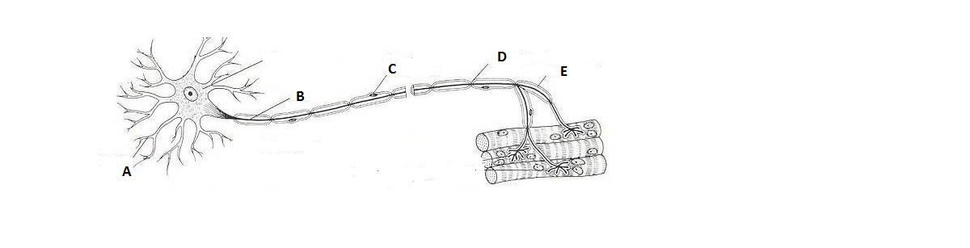

1. Point D allows conduction of impulses to be up to 50 times faster than through the fastest unmyelinated axons. Explain this statement.

(7 marks)

_____________________________________________________________________________________________________________________________________________________________________________________________________________________________________________________________________________________________________________________________________________________________________________________________________________________________________________________________________________________________________________________________________________________________________________________________________________________________________________________________________________________________________________________________________________________________________________________________________________________________________

II. Classify this neuron by function.

___________________________________________________________

(1 mark)

III. Classify this neuron by morphology. Give a reason for your choice.

________________________________________________________________________________________________________________________________________________________________________________________________________________________________________________________

1. marks)

3. Pheochromocytoma is a disorder where a tumor forms in the area of the adrenal gland labeled A in the diagram below. It causes an overproduction of the hormones secreted by this part of the gland. Two of the symptoms of pheochromocytoma are high blood pressure and elevated heart rate.

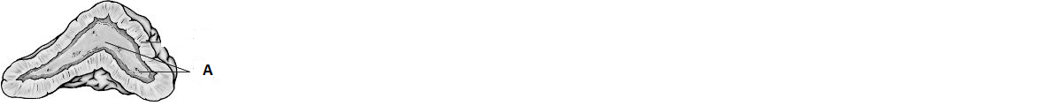

Explain why pheochromocytoma might cause these symptoms.

(5 marks)

__________________________________________________________________________________________________________________________________________________________________________________________________________________________________________________________________________________________________________________________________________________________________________________________________________________________________________________________________________________________________________________________________________________________________________________________________________________________________________________________________________________________________________

**4.** To maintain thyroid function and a normal basal metabolic rate(BMR), a series of events must take place involving the thyroid gland and its interaction with two other structures in the body. Describe the series of events involving the thyroid gland and these two other structures that would occur to prevent a healthy person’s BMR from dropping to below normal levels.

(5 marks)

_______________________________________________________________________________________________________________________________________________________________________________________________________________________________________________________________________________________________________________________________________________________________________________________________

1. Chose two (2) pituitary hormones, one from each lobe, and describe their effects and respective target cells or organs.

(6 mark)

_______________________________________________________________________________________________________________________________________________________________________________________________________________________________________________________________________________________________________________________________________________________________________________________________

_______________________________________________________________________________________________________________________________________________________________________________________________________________________________________________________________________________________________________________________________________________________________________________________________

1. Compare and contrast the sympathetic and parasympathetic nervous systems.

(9 marks)

________________________________________________________________________________________________________________________________________________________________________________________________________________________________________________________________________________________________

________________________________________________________________________________________________________________________________________________________________________________________________________________________________________________________________________________________________________________________________________________________________________________________________________________________________________________________________________________________________________________________________________________________________________________________________________________________________________________________________________

________________________________________________________________________________________________________________________________________________________________________________________________________________________________________________________________________________________________

_______________________________________________________________________________________________________________________________________________________________________________________________________________________________________________________________________________________________________________________________________________________________________________________________________________________________________________________________________________________________________________________________________________________________________________________________________________________________________________________________________

________________________________________________________________________________________________________________________________________________________________________________________________________________________________________________________________________________________________

________________________________________________________________________________________________________________________________________________________________________________________________________________________________________________________________________________________________________________________________________________________________________________________________________________________________________________________________________________________________________________________________________________________________________________________________________________________________________________________________________

_____________________________________________________________________________________________________________________________________________________________________________________________________________________________________________________­­­­­­­­­­­­­­­­­­­­­­­­­­­­­­__________________________________________

________________________________________________________________________________________________________________________________________________________________________________________________________________________________________________________________________________________________________________________________________________________________________________________________________________________________________________________________________________________________________________________________________________________________________________________________________________________________________________________________________